
SULTAN QABOOS UNIVERSITY
COLLEGE OF SCIENCE
DEPARTMENT OF COMPUTER SCIENCE
COMP3205: INTRODUCTION TO DATABASE SYSTEMS
Tourism Management Database System in Oman

Project Part 4
Done by:
| Shahad Al Ghassani 133140
| Khulood Al Hosni 136968
| Mariam Al Rashdi 141535

Table of Contents
DB Queries: 3
Views: 10
Relational Algebra: 12
Q1: 12
Q2: 12
Q5-Nested Query: 12
Q6-Nested Query: 13
Query Optimization tree: 14

DB Queries:

Using One Table :

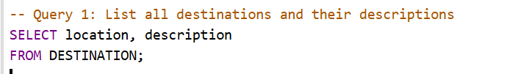

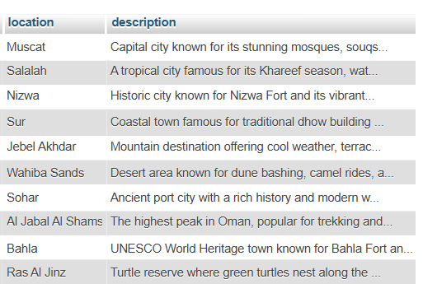

Using Multiple Tables:

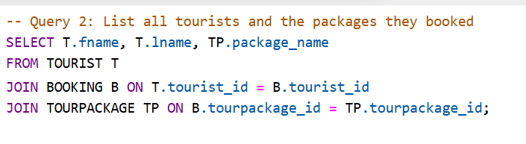

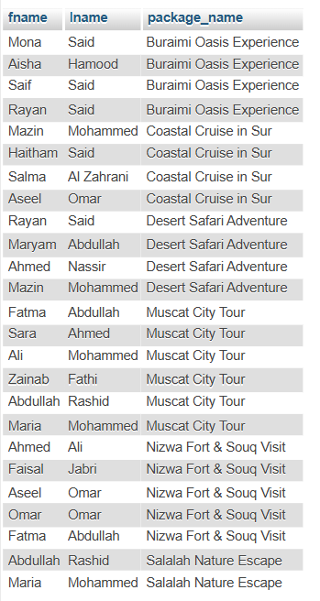

Using LIKE

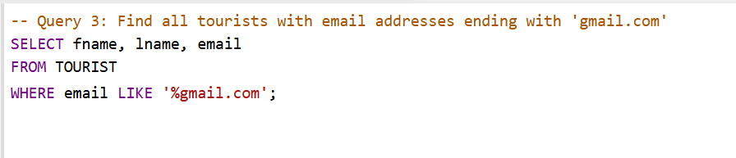

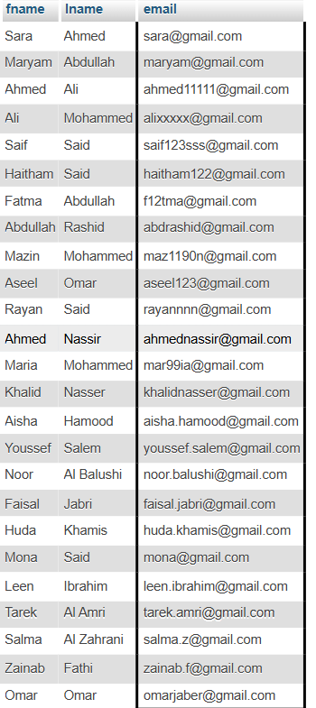

Using Aggregate Function + Rename

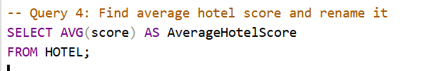



(Nested Query + GROUP BY + HAVING)

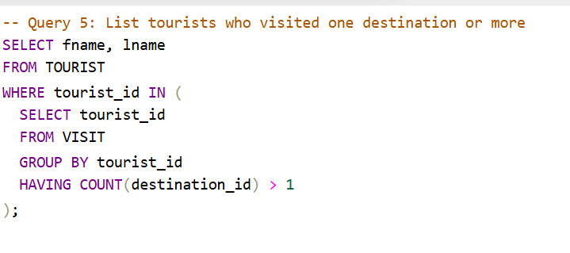

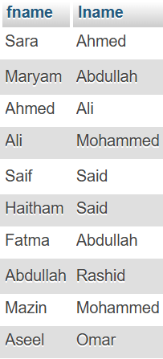

6 – Using EXISTS + NOT NULL

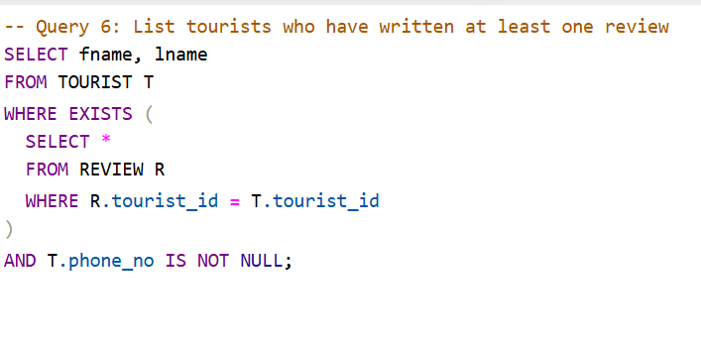

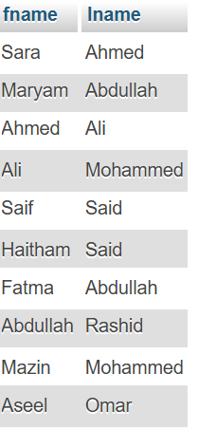

ORDER BY

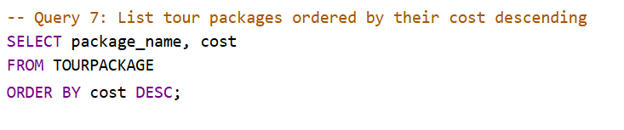

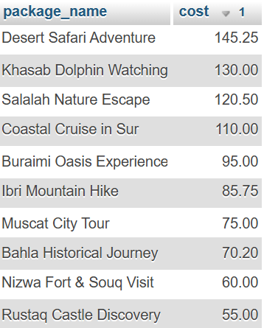

Views:

View 1: Simple View (Single Table)

Display the first name, last name, and nationality of tourists who are from Oman.

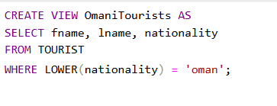



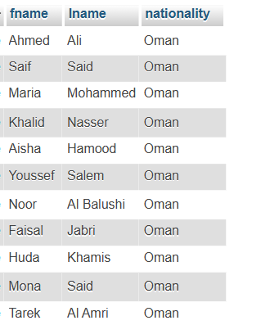

View 2: Complex View (Multiple Tables + Group By)

Display the tourist's first name, last name, and the number of bookings they made.

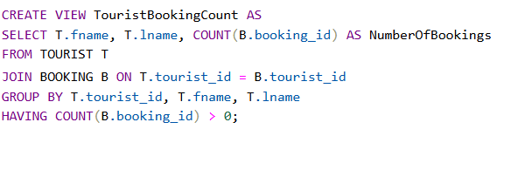

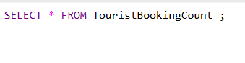

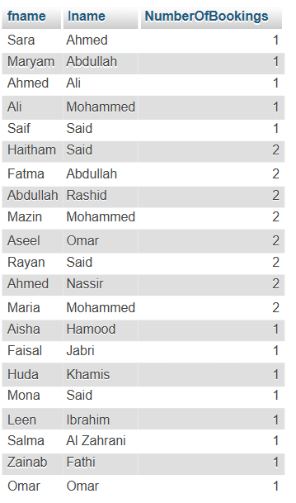

Relational Algebra:

Q1:

Query: List all destinations and their locations and descriptions.
- Sequence of Relational Algebra Operations:
ρ D (DESTINATION)
π (location, description) (D)
- Single In-line Relational Algebra Expression:
π (location, description) (DESTINATION)
Q2:
Query: List all tourists and the packages they booked.
- Sequence of Relational Algebra Operations:
TOURIST_BOOKINGS ← TOURIST ⋈ TOURIST.tourist_id = BOOKING.tourist_id BOOKING
TOURIST_PACKAGES ← Tourist_booking ⋈ BOOKING.tourpackage_id = TOURPACKAGE.tourpackage_id TOURPACKAGE
RESULT ← π (TOURIST.fname, TOURIST.lname, TOURPACKAGE.package_name) (TOURIST_PACKAGES)
- Single In-line Relational Algebra Expression:
π (TOURIST.fname, TOURIST.lname, TOURPACKAGE.package_name)
((TOURIST ⋈ TOURIST.tourist_id = BOOKING.tourist_id BOOKING)
⋈ BOOKING.tourpackage_id = TOURPACKAGE.tourpackage_id TOURPACKAGE)

Q5-Nested Query:

Query: List tourists who visited more than one destination.
- Sequence of Relational Algebra Operations:
#Rename VISIT twice for self-join
ρ V1 (VISIT)
ρ V2 (VISIT)
#Find tourists who visited at least two different destinations
V3 ← σ V1.tourist_id = V2.tourist_id ∧ V1.destination_id ≠ V2.destination_id (V1 ⋈ V2)
#Project distinct tourist IDs from V3
T ← π V1.tourist_id (V3)
#Join with TOURIST to get names
Tourists ← TOURIST ⋈ TOURIST.tourist_id = T.tourist_id
Result ← π (fname, lname) (Tourists)
- Single In-line Relational Algebra Expression:
π fname, lname ( TOURIST ⋈ ( π V1.tourist_id ( σ V1.destination_id ≠ V2.destination_id ∧ V1.tourist_id = V2.tourist_id ( ρ V1 (VISIT) ⋈ ρ V2 (VISIT))))

Q6-Nested Query:

Query: List tourists who have written at least one review and have a phone number.
- Sequence of Relational Algebra Operations:
ρ T (TOURIST)
ρ R (REVIEW)
Tourist_Review ← T ⋈ T.tourist_id = R.tourist_id
Tourist_Phone ← σ (T.phone_no IS NOT NULL) (Tourist_Review)
Result ← π (fname, lname) (Tourist_Phone)
- Single In-line Relational Algebra Expression:
π (fname, lname) (σ (phone_no IS NOT NULL) (TOURIST ⋈ REVIEW))

Query Optimization tree:
- For query #2:
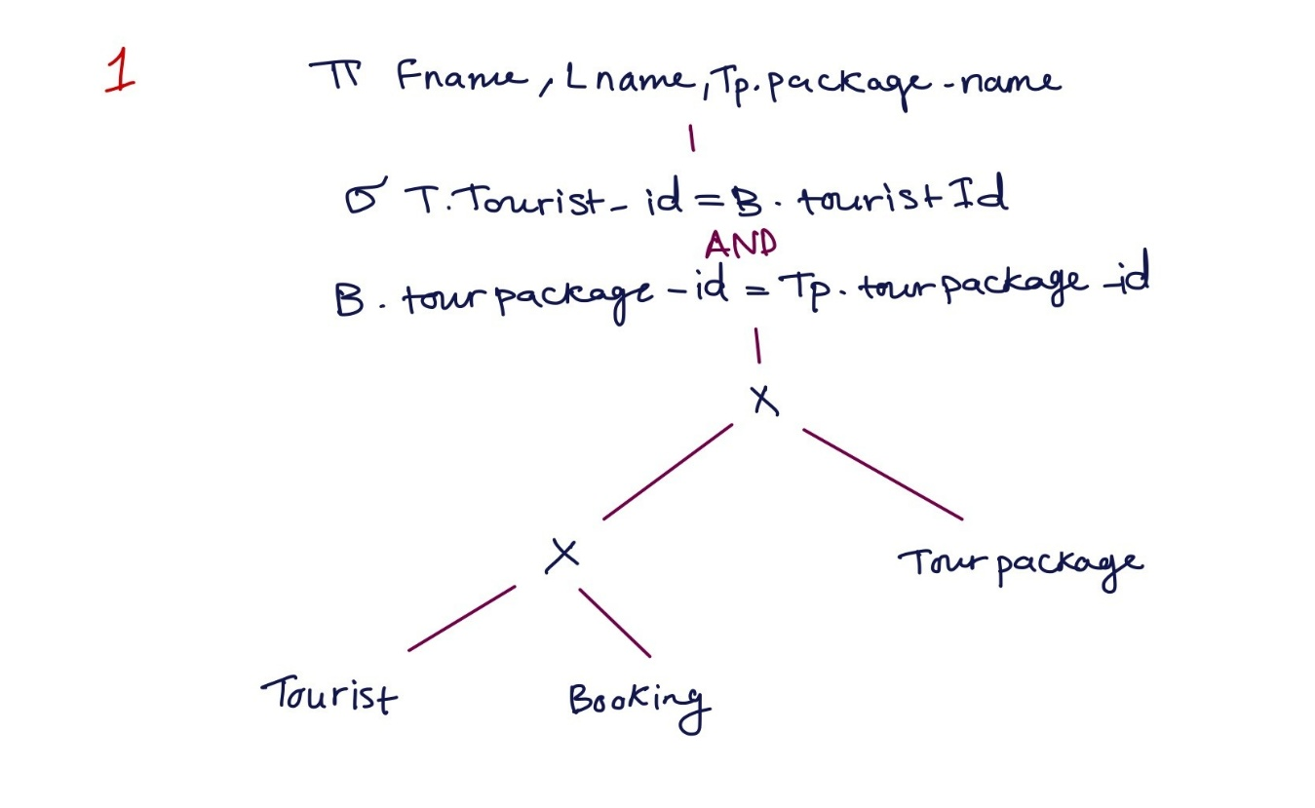_________________________________________________________________________________
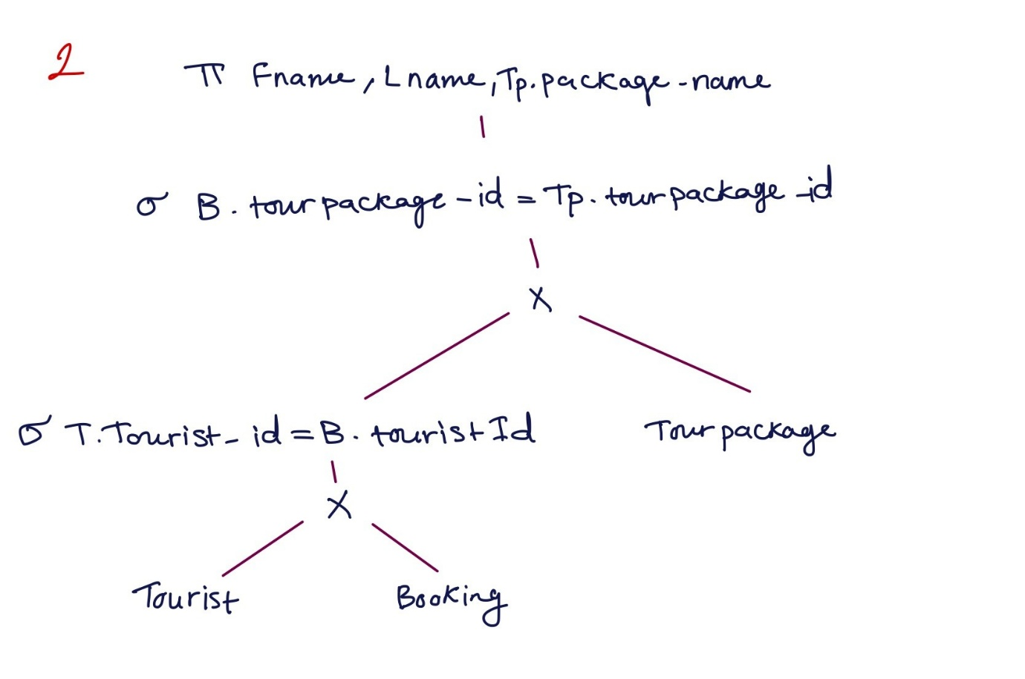
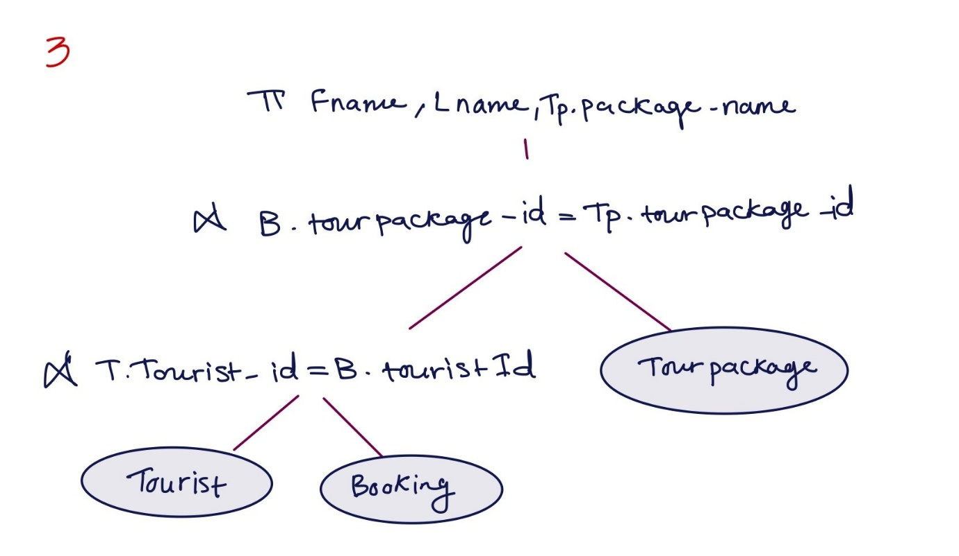
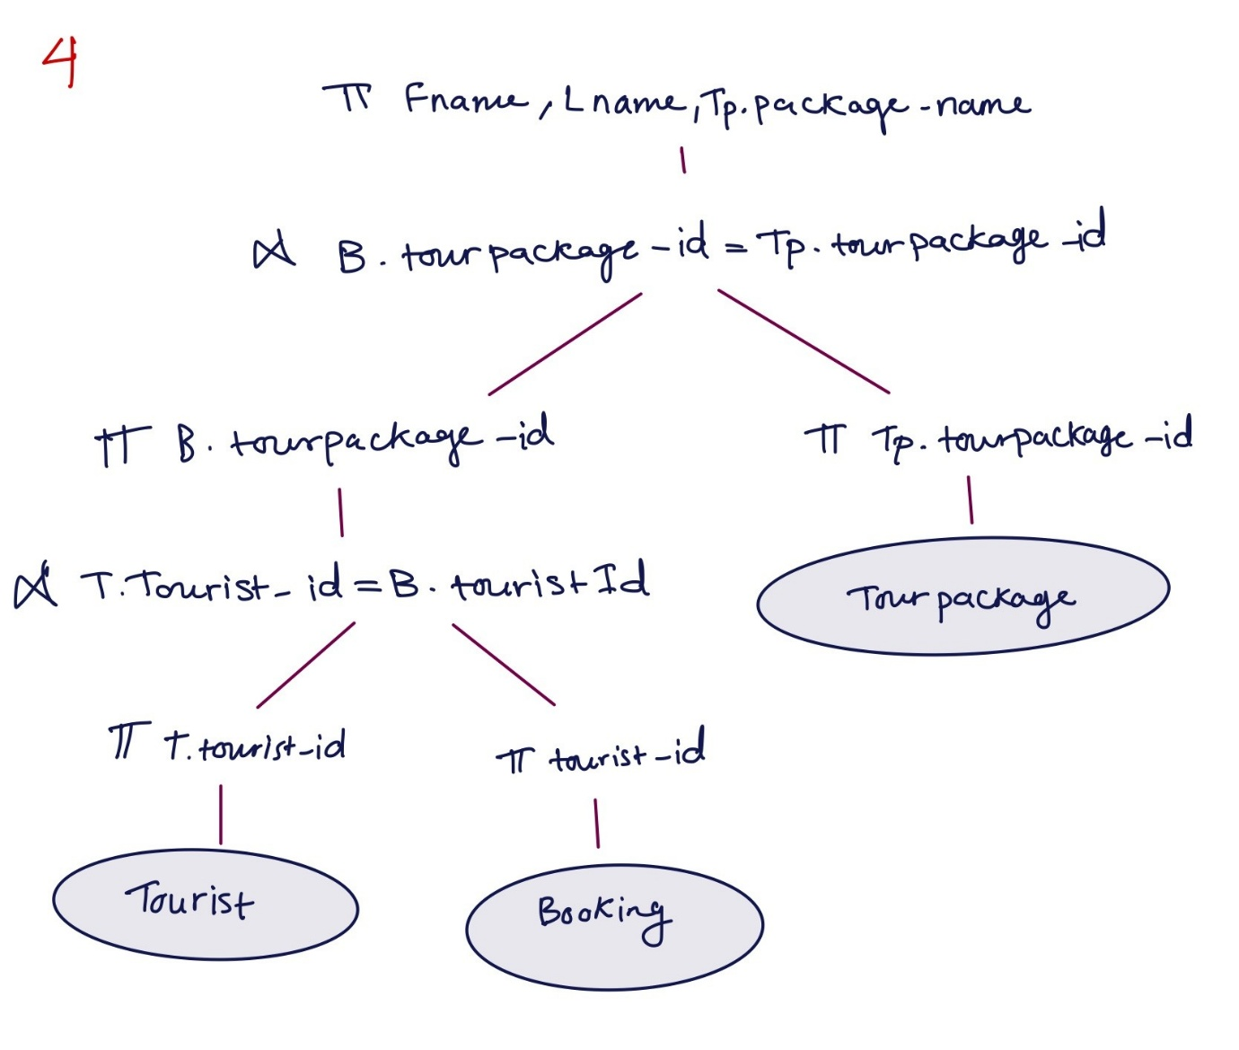
The query tree for this SQL statement is optimized as it adheres to a logical and efficient sequence of operations. It begins by connecting the TOURIST and BOOKING tables through the tourist_id, which is a foreign key in the BOOKING table. This join assists in filtering and minimizing extraneous data early on in the procedure. Next, it combines the outcome with the TOURPACKAGE table by using tourpackage_id, which is also a foreign key in the BOOKING table. This stage guarantees that solely pertinent package details are incorporated. Ultimately, the query implements projection to choose exclusively the necessary columns: first name, last name, and package name. This prevents extra columns from being included in the query, aiding in better performance. Since the joins utilize foreign key relationships and the projection occurs at the end, the query tree bypasses redundant processing, leading to an efficient and optimized outcome.

- For query #6:
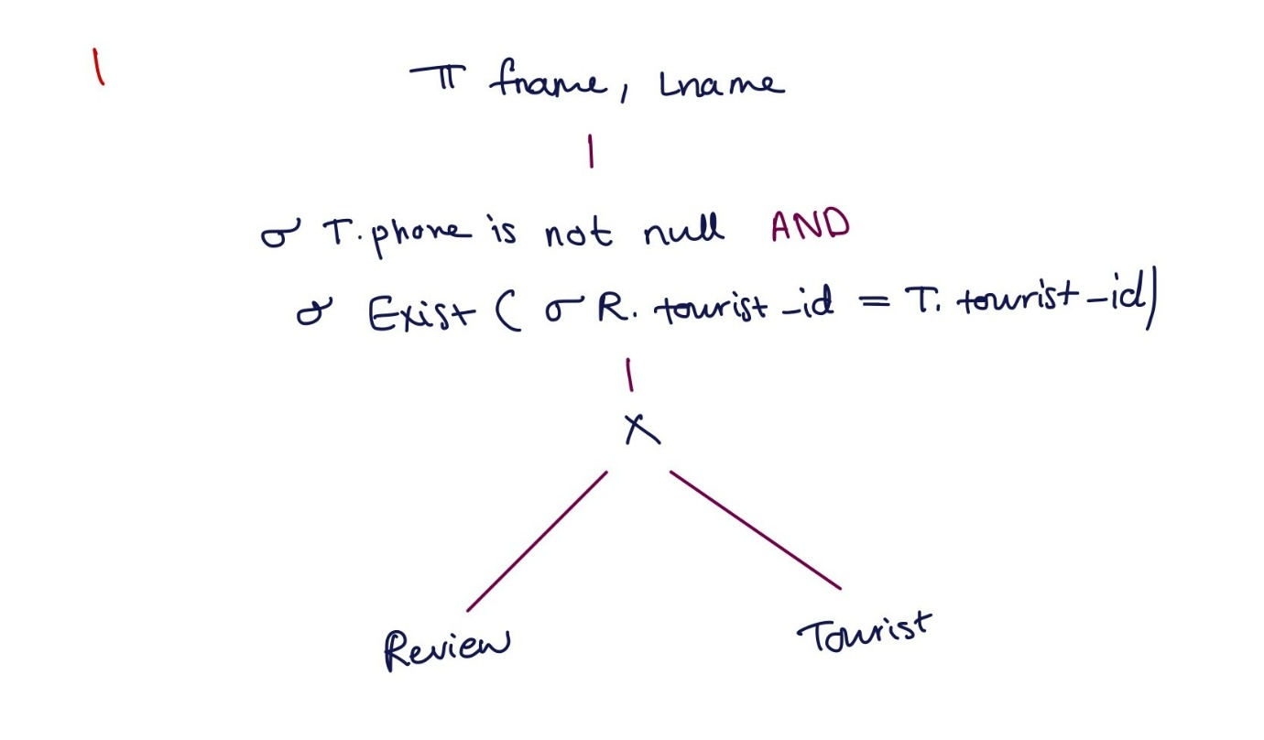_______________________________________________________________________________
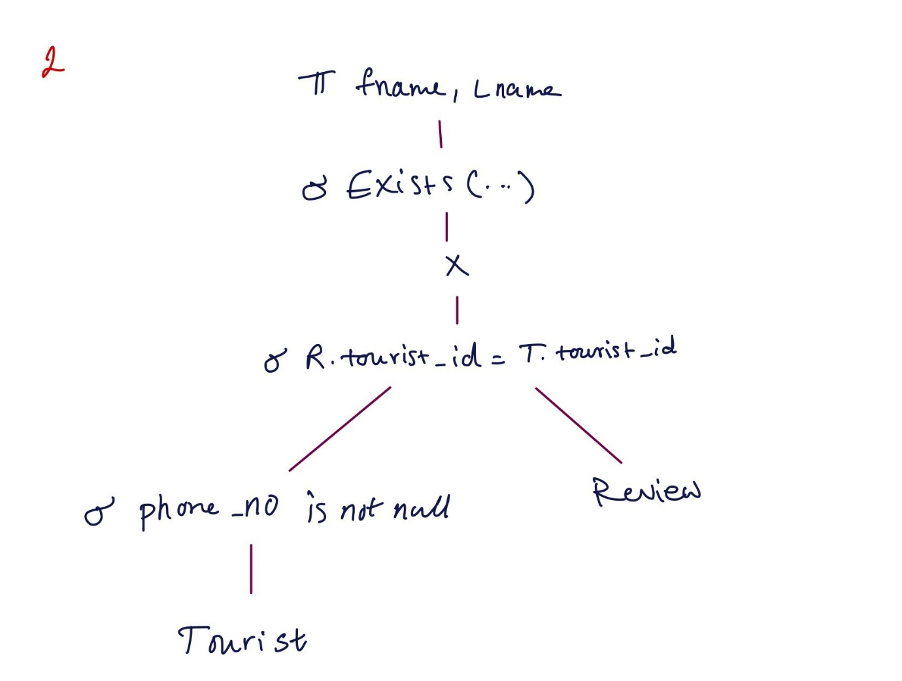

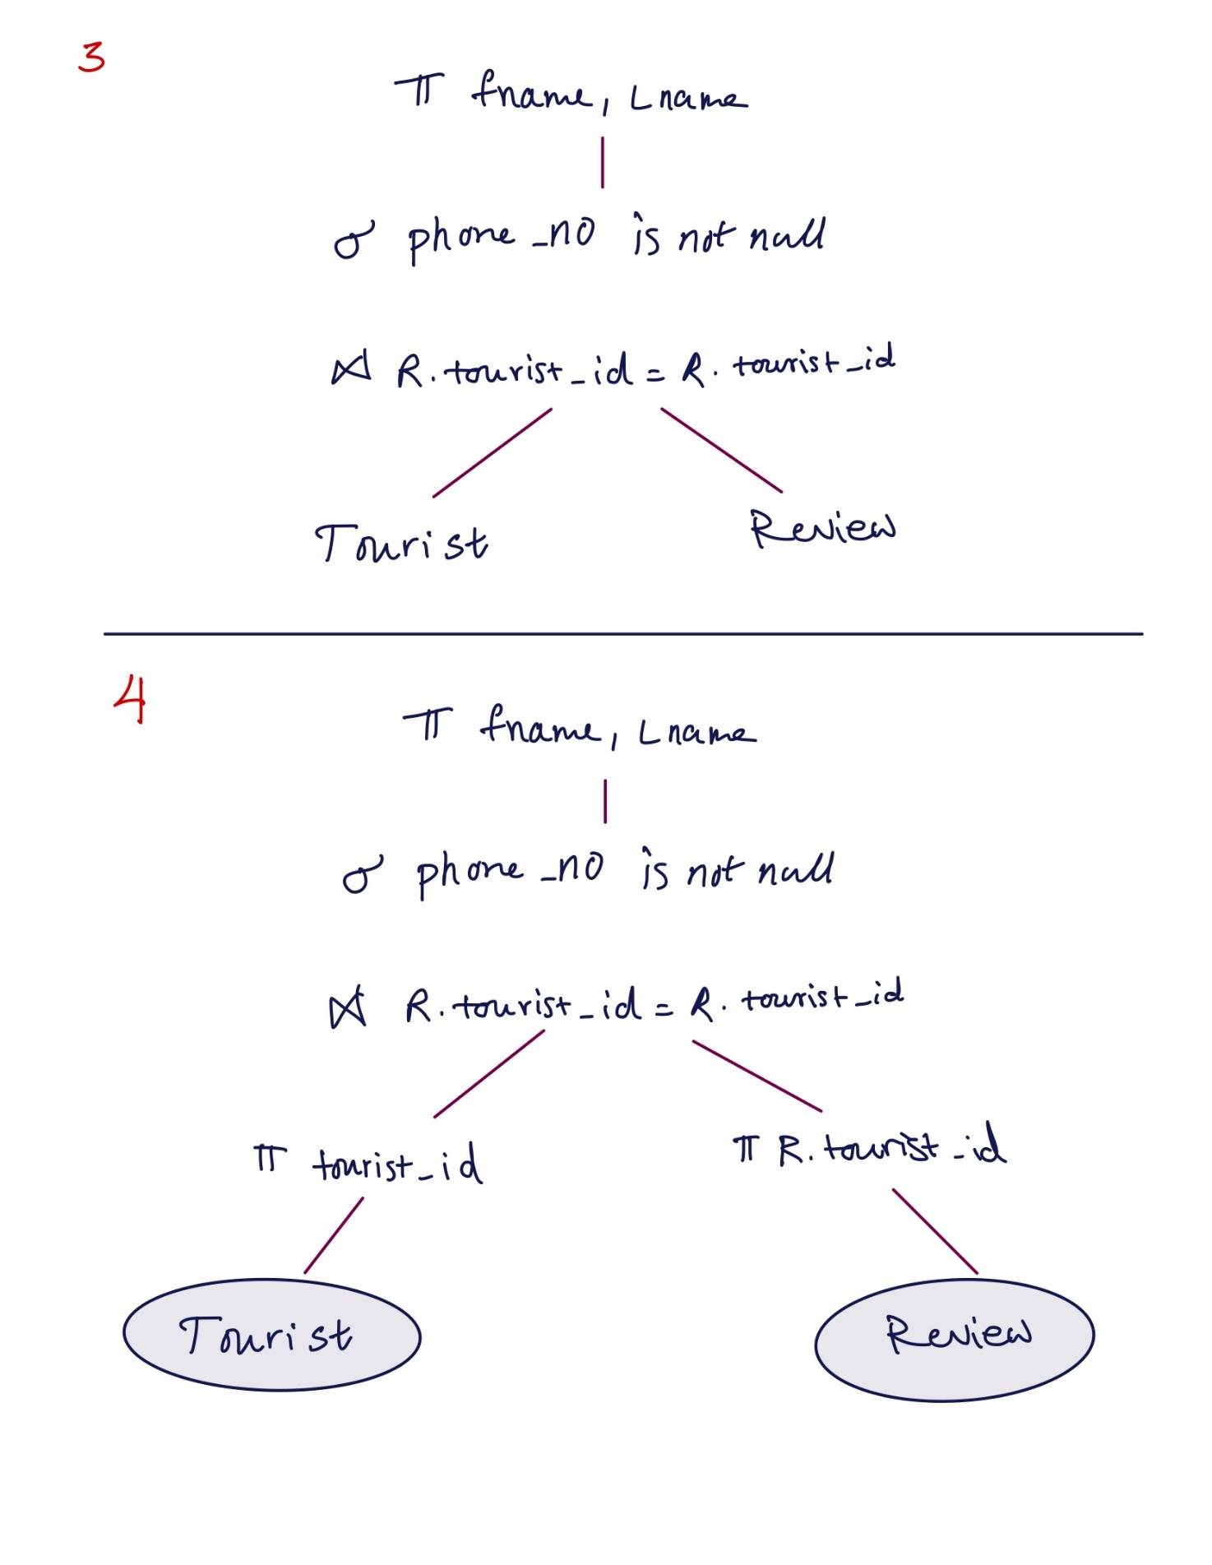

The built query tree is deemed optimal as it adheres to various key optimization procedures. Initially, it circumvents the application of Cartesian Product by substituting it with a direct join between the TOURIST and REVIEW tables on the condition that their tourist_id values correspond. This greatly decreases the count of irrelevant combinations and enhances the efficiency of the query. Secondly, the condition T.phone_no IS NOT NULL is enforced as soon as possible in the tree, immediately following the join, which aids in eliminating irrelevant rows quickly and decreases the size of intermediate outcomes. Finally, the projection operation that chooses solely the fname and lname attributes is positioned at the top of the tree, guaranteeing that only essential columns are sent to the final output. These actions enhance the query's performance, resulting in a tree that is both organized and efficient.

